Agentic Ai :
Agentic Ai is a type of Ai where it can able to make its own decisions ,take action , and even learn on its own to achieve specific goals . It’s kind of like having a virtual assistant that can think, reason, and adapt to changing circumstances without needing constant direction. Example self driving cars.
It operates in four stages.
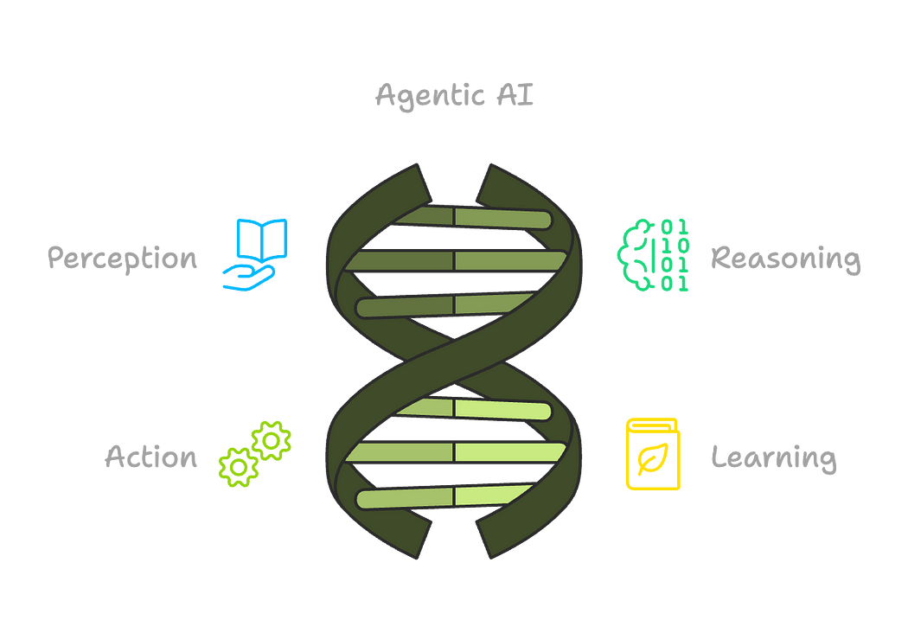
Use case for Agentic Ai:
Agentic Ai in logistics and Supply Chain
Use Case Overview : Agentic Ai helps companies manage their supply chain automatically. Agentic Ai monitors the inventory , predicts what will be needed next, and places orders on time (it will maintain the stock if stock is getting completed then it will re- order the stock). It also finds the best delivery routes using data . It also helps for the consumers by providing live tracking and updates of the delivery.
1. Supply Chain Optimization:
Demand Forecasting:
AI can predict future demand based on historical data, market trends, and external factors, allowing for better inventory planning and production scheduling.
Inventory Management:
AI can optimize inventory levels by identifying optimal restocking points, minimizing waste, and ensuring timely availability of goods.
Procurement:
AI can analyze supplier data, identify potential cost-saving opportunities, and negotiate contracts more effectively.
Capacity Planning:
AI can predict production capacity needs and optimize resource allocation to meet demand.
2. Logistics Optimization:
Route Optimization:
AI can dynamically adjust delivery routes based on traffic, weather, and other real-time conditions, reducing fuel consumption and delivery times.
Fleet Management:
AI can monitor vehicle performance, detect potential maintenance issues, and optimize fleet deployment for maximum efficiency.
Warehouse Automation:
AI can automate warehouse operations, including sorting, picking, packing, and inventory tracking, reducing labor costs and errors.
3. Risk Management and Resilience:
Predictive Maintenance:
AI can predict equipment failures and proactively schedule maintenance, minimizing downtime and costly repairs.
Disruption Detection:
AI can monitor supply chain conditions in real-time and identify potential disruptions, allowing for timely intervention and mitigation strategies.
Alternative Sourcing:
AI can identify alternative suppliers and routes in case of disruptions, ensuring business continuity.
4. Other Applications:
Dynamic Pricing:
AI can adjust prices based on real-time demand and market conditions, optimizing revenue.
Customer Service:
AI-powered chatbots can provide real-time updates on shipment status and address customer inquiries.
Compliance and Security:
AI can monitor supply chain operations for compliance with regulations and identify potential security risks.

It will take feedback from user and again it will feed to the model.

